Power BI Hands-on Assessment

Aditya Abhinav

1)Downloaded sql script from github.

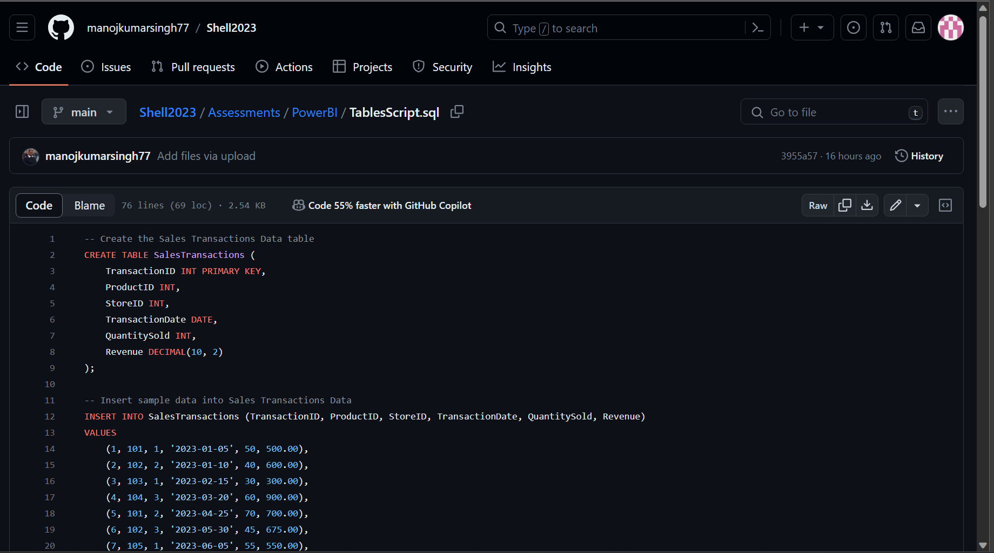

Database Created and table created.

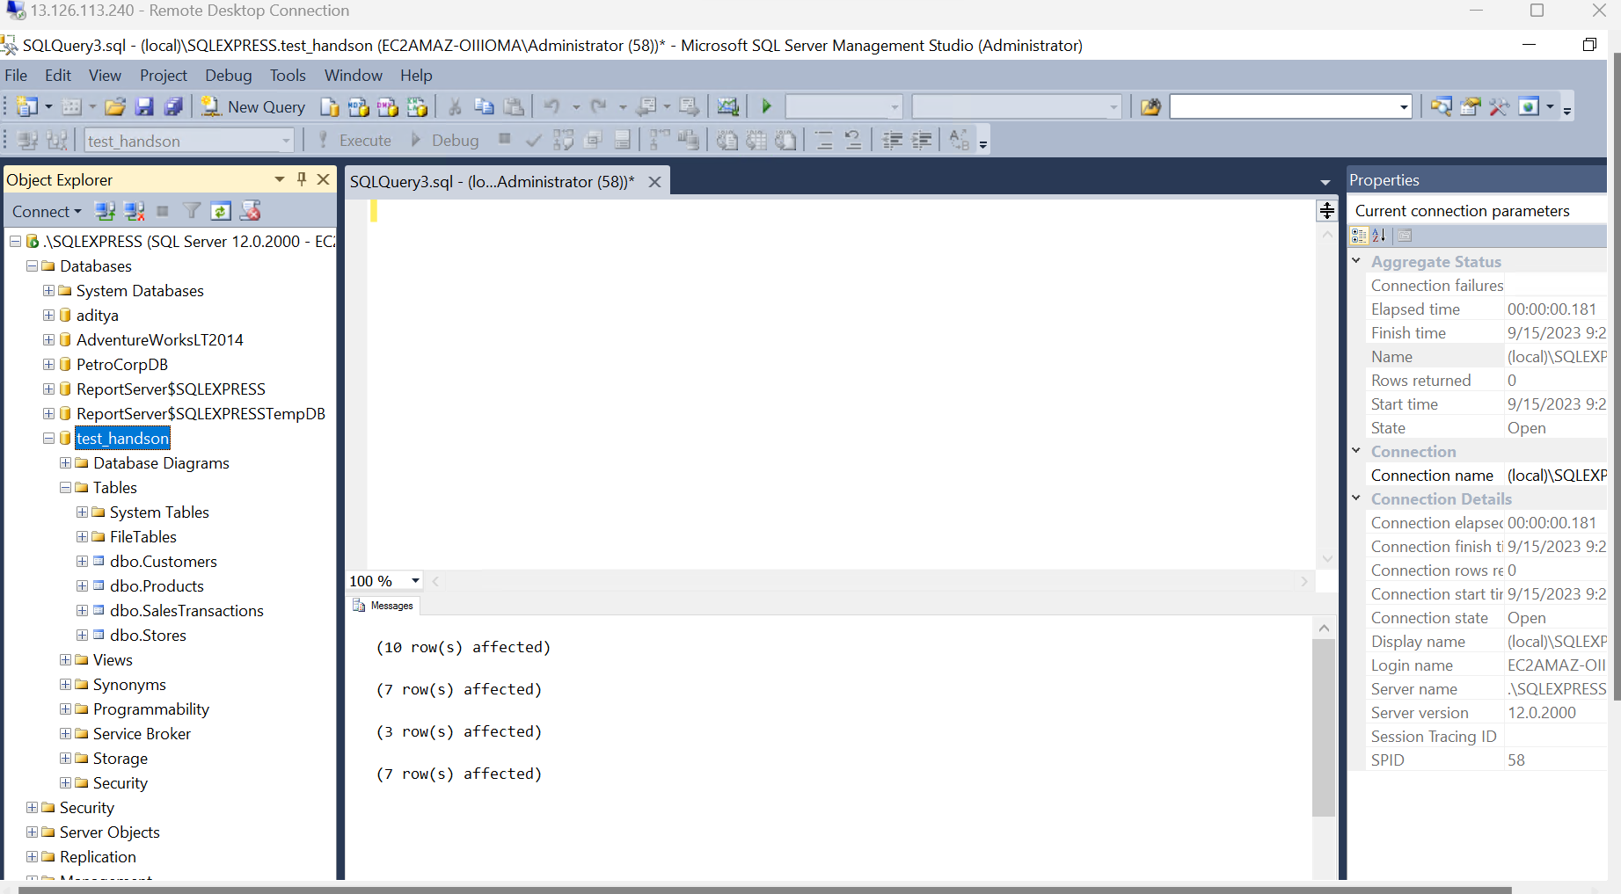

Loading data on Power BI

2)Data Transform

2.1 Merging

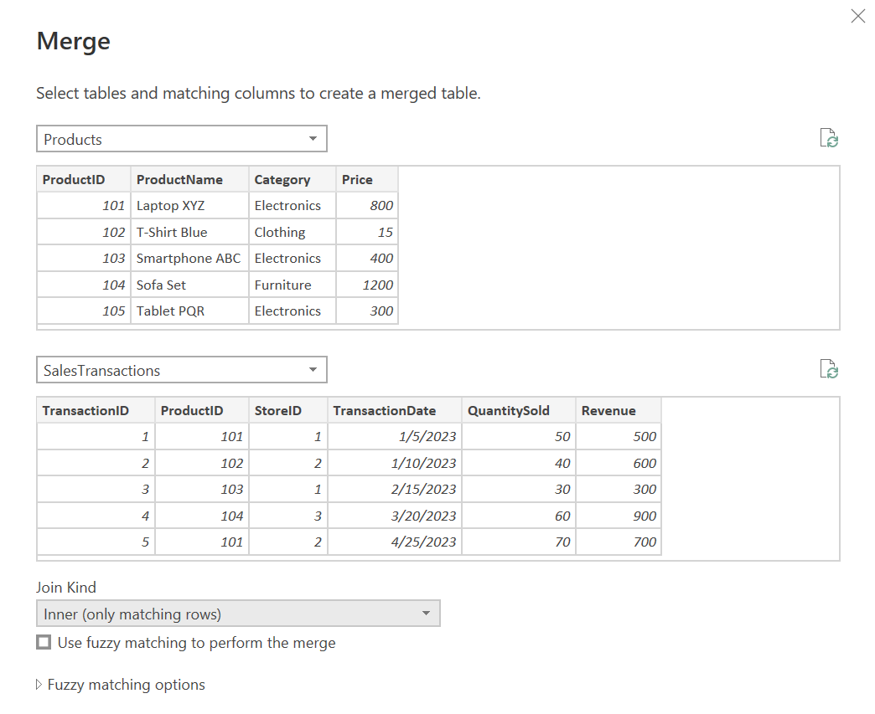

2.2 Clean Data (Changed the data type of phone number from string to whole number using replace to remove (),- )

Before cleaning.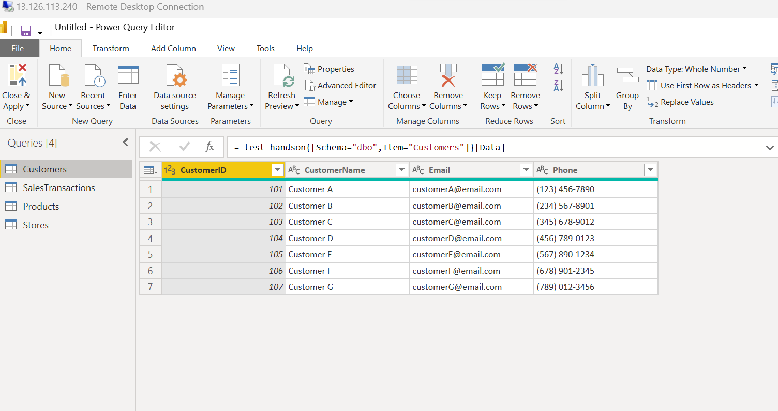

After Cleaning.

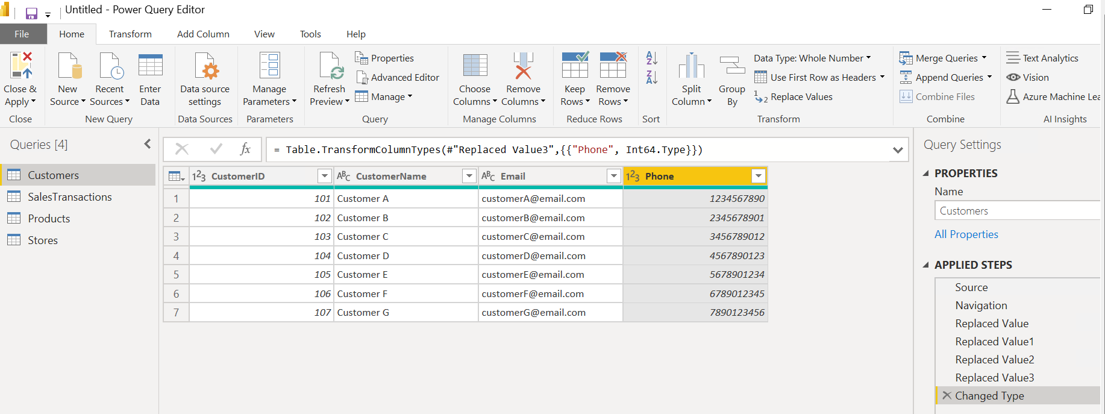

2.3 Created a calculated column (Price/Unit)

2.4 Filter Data

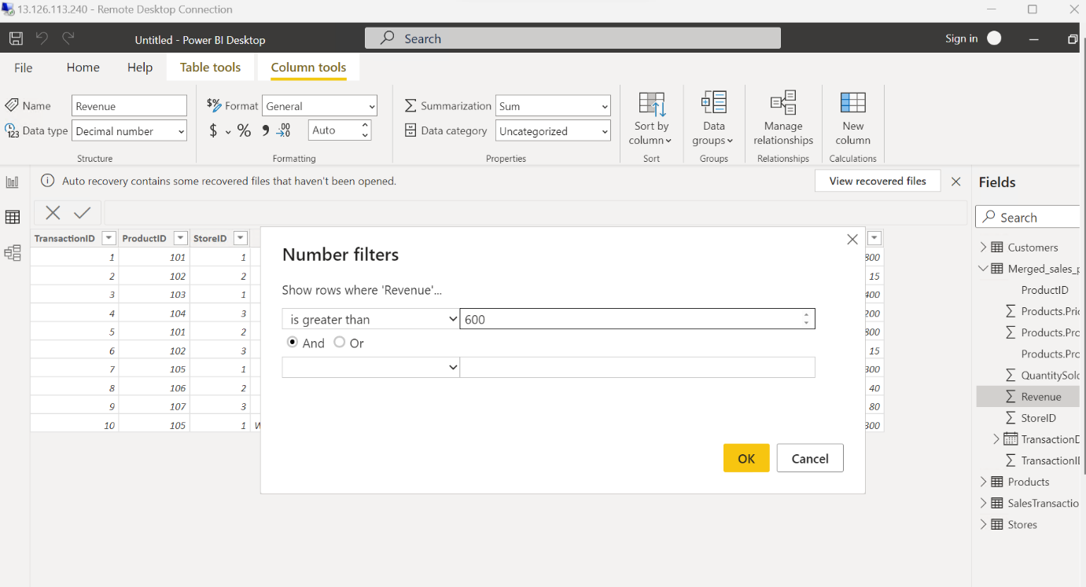

Used Filter on Quantity Sold and Revenue

3 Data Modelling

3.1 Create Relationships:

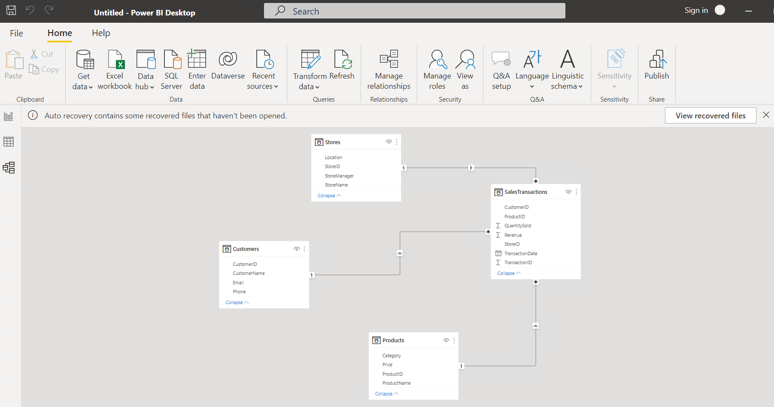

3.2 Create Hierarchies

4 Business Queries and Analysis

4.1 Who are the top-spending customers based on their total purchase amount?

Ans- 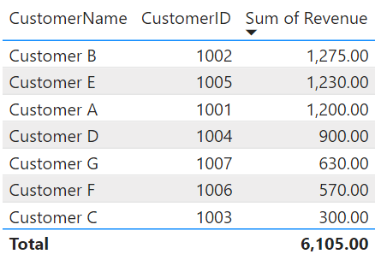

4.2 How is sales revenue distributed among different store managers?

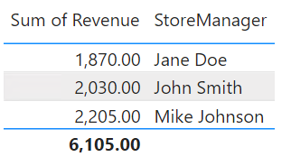

4.3 What is the average price of products in each category?

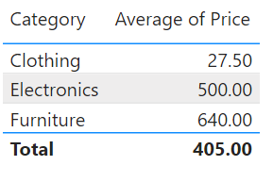

4.4 Are there specific days of the week when sales are higher?

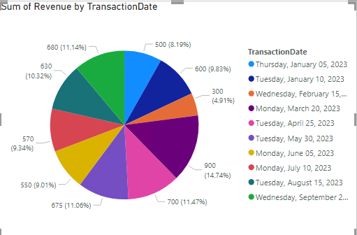

5. How do sales trends vary by product category on a monthly basis?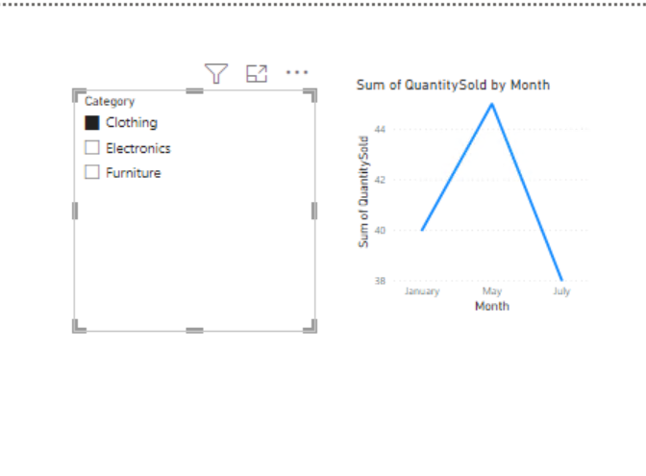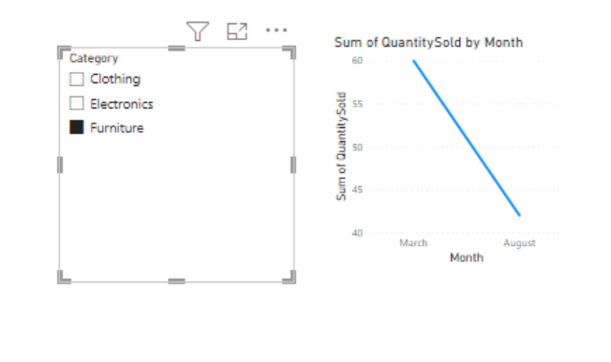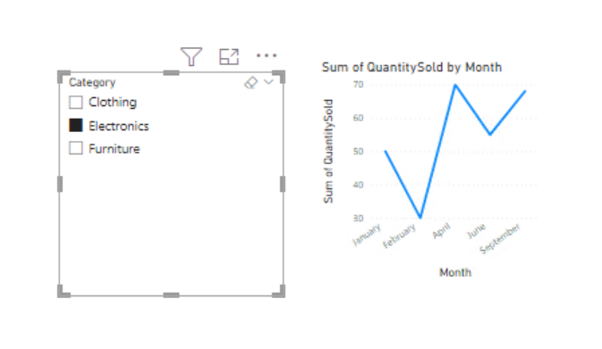

6. What percentage of products account for 80% of total sales revenue?

